CIS101 - Setting up and Using CoreFTP

What is CoreFTP?
FTP stands for File Transfer Protocol, a mechanism for transferring (copying) files over the internet. You can use FTP to exchange files between computer accounts, to transfer files between an account and a desktop computer, or to access software archives on the Internet. CoreFTP is a shareware utility that facilitates the transfer of files between computers.

Access CoreFTP Click on the icon on the desktop or find the file under programs.
You will use CoreFTP to upload your HTML files into your personal Web space. In order for the file transfer to work properly, you need to enter the following settings:

Site Name: Anything or leave it blank
Host/IP/url webpage.pace.edu (nothing else)
User name: mc45678p ( not really – use your user name)
Password: ******** use the password that you use for Portal
Make sure AUTH TLS is clicked on under Connection
Click Connect - you will get a message that you are connected.
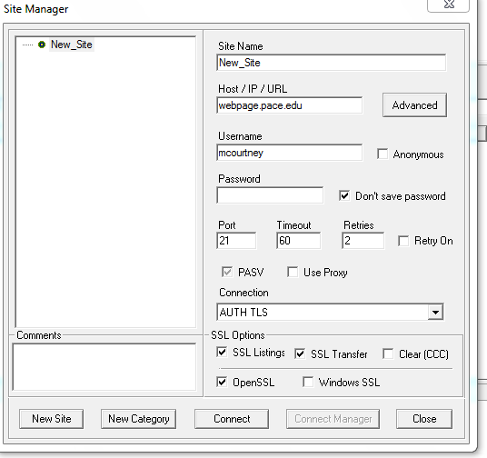

- Let’s be organized. On the right hand side of the screen, we will create a folder ( or directory ) or today’s classwork and homework. Click on the folder (+) icon, and type in for the folder name HTMLChapterTwo andHW6

- On the left hand side of the screen, access the a: drive where your html files are located. ( You may have to change the directory –click on the icon next to the spy glass ) Locate the file you want to store on the website. With a file highlighted, click on the blue → to bring the file (RockClimbing.html) to your web space(right hand side) . You can also highlight a file and drag it to the other side.

- How do you know if it worked? Access Internet Explorer to view your website

What is the URL of your new Web site?
http://webpage.pace.edu/YourID ( no www.)

Where YourID is your e-mail address

- Why is there no picture in your website? Because you didn’t put in your webspace. Go back to coreftp . You may need to sign in again. Find rockclimber.jpg and send it over to the right into the folder HTMLChapterTwo andHW6

Where to find CoreFTP for your personal computer:
You can download a free copy of CoreFTP for your home computer at http://www.coreftp.com You can choose either CoreFTP Professional or CoreFTP lite

